**Course Specialist Test 3 Year 12**

Student name: ________________ Teacher name: ________________

**Task type: Response**

**Time allowed for this task: ____40_______ mins**

**Number of questions: _____7______**

**Materials required:** Calculator with CAS capability (to be provided by the student)

Standard items: Pens (blue/black preferred), pencils (including coloured), sharpener, correction fluid/tape, eraser, ruler, highlighters

Special items: Drawing instruments, templates, notes on one unfolded sheet of   
A4 paper, and up to three calculators approved for use in the WACE examinations

**Marks available: _44_____ marks**

**Task weighting: _10___%**

**Formula sheet provided: Yes**

**Note: All part questions worth more than 2 marks require working to obtain full marks.**

Q1 (6 marks)

1. Solve the following system of linear equations. (3 marks)



|  |
| --- |
| **Solution** |
|  |
| **Specific behaviours** |
| 🗸 eliminates one variable from two equations  🗸 eliminates two variables  🗸 solves for all variables |

1. Determine all possible values of  for the three scenarios below. (3 marks)



1. No solutions
2. One solution
3. Infinite solutions

|  |
| --- |
| **Solution** |
|  |
| **Specific behaviours** |
| 🗸 derives equation with two variables eliminated  🗸 states values for uniqueness  🗸 states values for no solution and infinite (follow through) |

Q2 (9 marks)

A particle moves with acceleration  at time  seconds. The initial velocity is  and initial position .

1. Determine the velocity at time  seconds. (2 marks)

|  |
| --- |
| **Solution** |
|  |
| **Specific behaviours** |
| 🗸 anti-differentiates  🗸 solves for constant |

1. Determine the position vector at time  seconds. (2 marks)

|  |
| --- |
| **Solution** |
|  |
| **Specific behaviours** |
| 🗸 determines r  🗸 approx. at t=5 (maybe exact or 2 dp) |

1. Determine  on the cartesian path at time  seconds. (2 marks)

|  |
| --- |
| **Solution** |
|  |
| **Specific behaviours** |
| 🗸 uses v at t=5  🗸 determines rate |

1. Determine  on the cartesian path at time  seconds. (3 marks)

|  |
| --- |
| **Solution** |
| Rate =0.00 |
| **Specific behaviours** |
| 🗸 time diff dy/dx  🗸 divides by dx/dt  🗸 determines approx. rate (do not penalise if not 2dp) |

Q3 (7 marks)

Consider an artificial island that contains a revolving light that is 250 metres from shore. There is a long wall on the shore and the light from the lighthouse can be seen as a moving dot of light on the wall. The angular speed of the light is 24 radians/second, ( ).

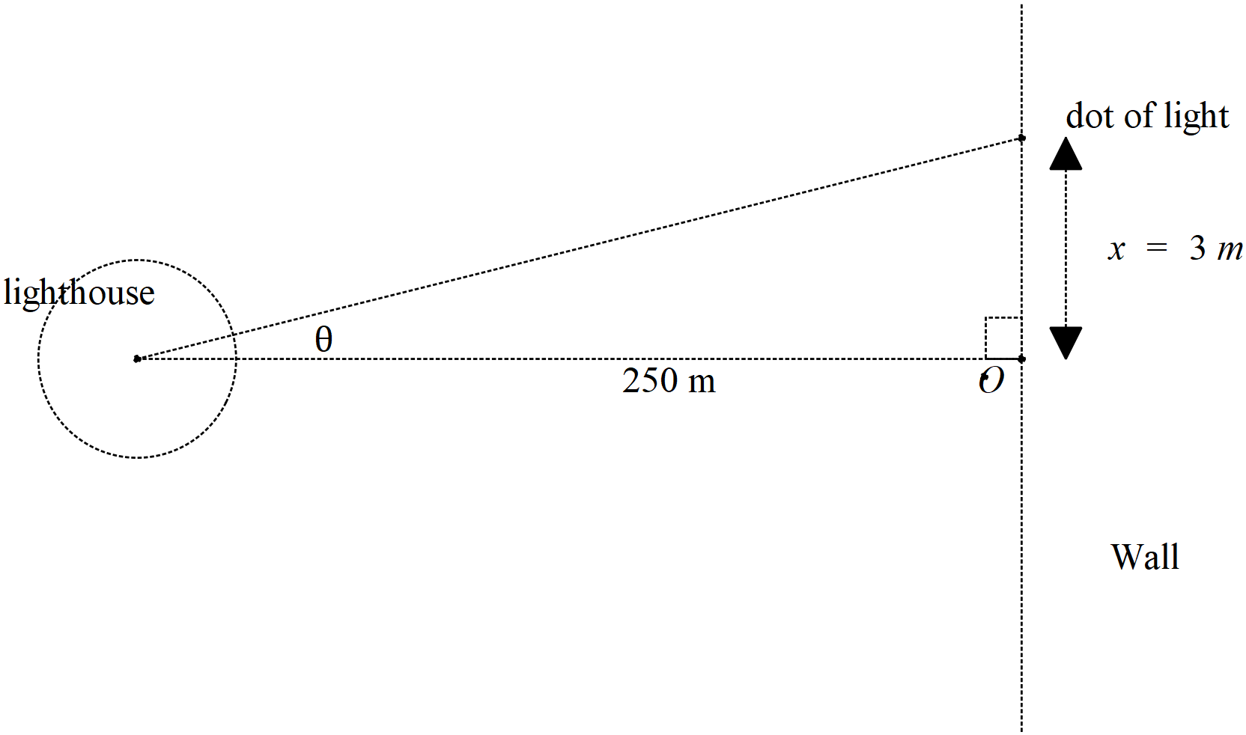

1. Determine the speed of the dot of light on the wall when the dot is 3 metres away from the closest point to the lighthouse, pt O, see diagram above. (4 marks)

|  |
| --- |
| **Solution** |
|  |
| **Specific behaviours** |
| 🗸 states relationship between x and angle  🗸 implicit diff wrt time (or related rates(  🗸 subs values and uses derivative of angle  🗸 determines approx. speed (no need for units) |

1. If the artificial island containing the lighthouse is moving towards the shore, pt O, at a speed of 5 metres per second, determine the speed of the dot when 3 metres away from pt O and the lighthouse being 170 metres from the shore, pt O. (3 marks)

|  |
| --- |
| **Solution** |
|  |
| **Specific behaviours** |
| 🗸 uses three variables  🗸 uses time implicit with product or quotient and all time rates with correct signs  🗸 determines speed |

Q4 (3 marks)

Show using logarithmic differentiation how to differentiate .

|  |
| --- |
| **Solution** |
|  |
| **Specific behaviours** |
| 🗸 tales natural log of both sides  🗸 implicit diff of both sides and uses product rule  🗸 expresses in terms of x&y |

Q5 ( 8 marks)

Show how to evaluate the following without any use of the classpad. Show all working.

1.  (4 marks)

|  |
| --- |
| **Solution** |
|  |
| **Specific behaviours** |
| 🗸 uses Pythagorean identity  🗸 breaks into two terms with sinx  🗸 anti- diffs both terms  🗸 subs both limits to give final result |

Q5 cont-

1.  (4 marks)

|  |
| --- |
| **Solution** |
|  |
| **Specific behaviours** |
| 🗸 uses partial fractions  🗸 solves for constants  🗸 integrates using logs  🗸 states answer with a plus constant |

Q6 (7 marks).

Consider a projectile that leaves with speed  at an angle  to the horizontal, see diagram. Assume that the constant acceleration is .

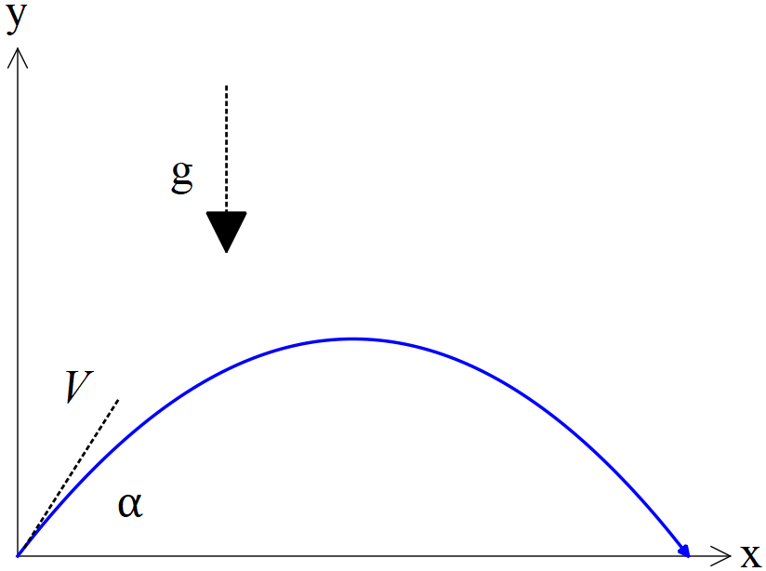

1. Using vector calculus and starting with the acceleration, show how to derive the cartesian equation of the path in terms of . (4 marks)

|  |
| --- |
| **Solution** |
|  |
| **Specific behaviours** |
| 🗸 integrates to find velocity and solves for constant  🗸 integrates to find r  🗸 subs x expression into y by eliminating t  🗸 obtains cartesian expression in terms of constants |

1. Given that  and that  when , determine possible value(s) for .

(3 marks)

|  |
| --- |
| **Solution** |
|  |
| **Specific behaviours** |
| 🗸 subs all knowns into cartesian equation  🗸 solves for one angle  🗸 solves for two angles |

Q7 (4 marks)

Consider the area between ,  and the x axis with , as shown below.

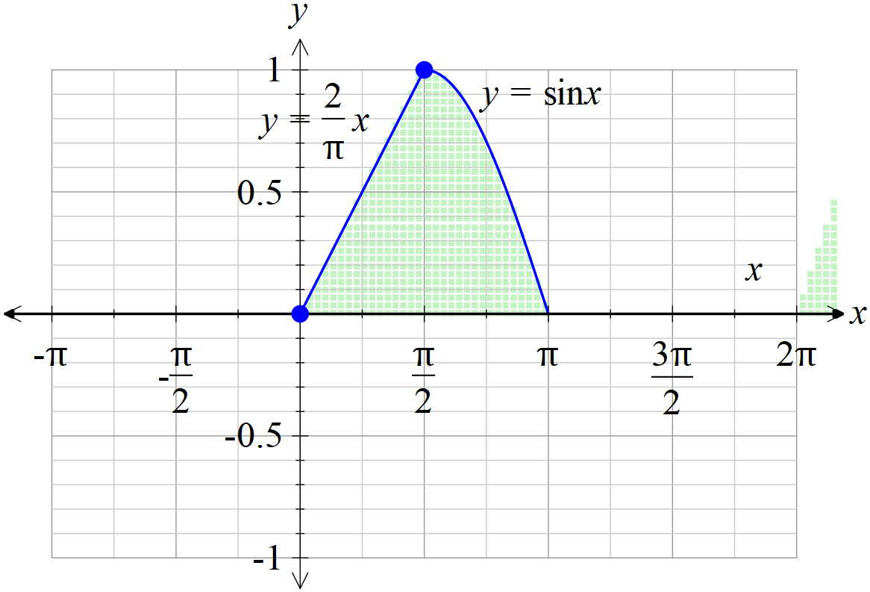

If the shaded area above is revolved around the y axis, determine the volume of the 3D object created.

|  |
| --- |
| **Solution** |
| (Note- use of inverse sine function without a translation is incorrect as sine x is a many to one function over 0 to pi domain) |
| **Specific behaviours** |
| 🗸 uses correct integral with appropriate limits for area under sin x  🗸 uses change of variable with correct order of limits  🗸 determines volume of cone  🗸 obtains correct volume -must be numeric  (no need to round)  (Max 1 out of 4 if revolved around x axis- too easy) |

r